**GAME INSTRUCTIONS**

This document provides detailed instructions on how to play the Hydrobot Adventure game.

1. Swimming Around

The little orange starfish on the screen is the cursor. When you click or hold the left mouse button, the hydrobot will swim towards the cursor.

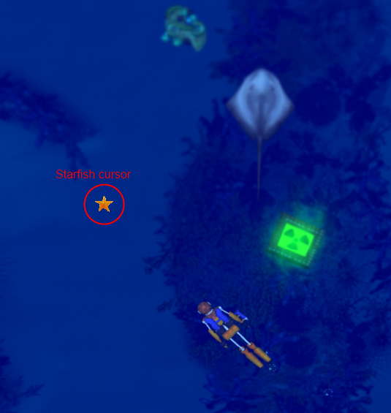

*Figure 1. Swimming around with the starfish cursor*

1. Build trash processing factories and research facilities

Left click on the factory building icons on the left bottom of the screen. Click again on the game arena to start building the factory or research facility. You need to have enough resources and space on the seabed to start construction.

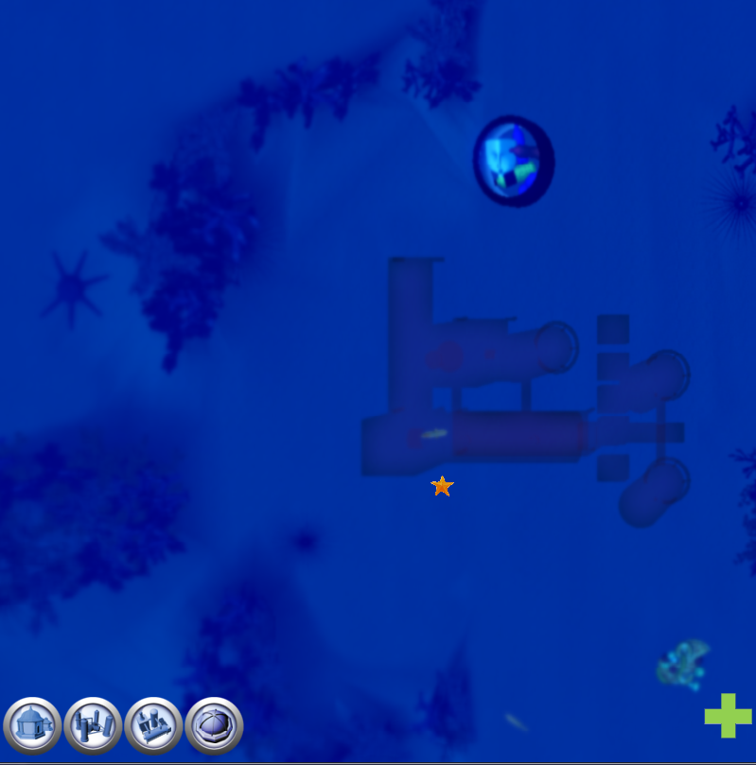

*Figure 2. Construct buildings*

1. Collect Trash

Position the hydrobot on top on the trash. Press ‘z’ to collect biodegradable trash. Press ‘x’ to collect plastic trash. Press ‘c’ to collect radioactive trash. You will hear a sound and see small fading numbers showing the points you gained.

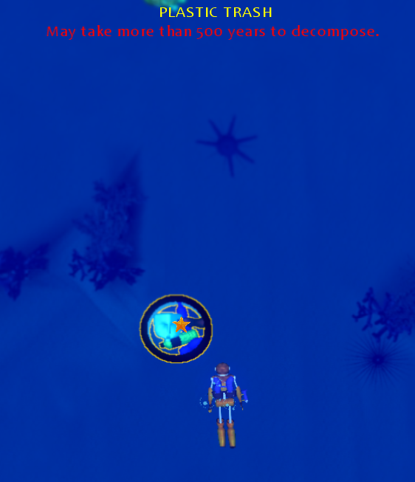

*Figure 3. Cleaning environment by collecting trashes*

1. Process Trash

Double click on trash processing factory to dump trash. The factory processes the trash and produce recycled resources that can be used to construct more facilities. Right click on a factory to open the factory configuration screen. You can change the configuration to produce powerpacks instead of resources.

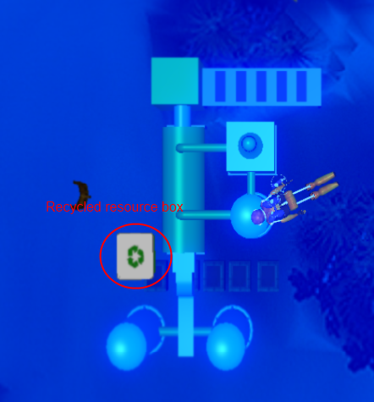

*Figure 4. Resource recycling with factory*

1. Collect resources and powerpacks

Position the hydrobot on top, and press ‘z’. You will hear a sound and see a small fading text displaying your gains.

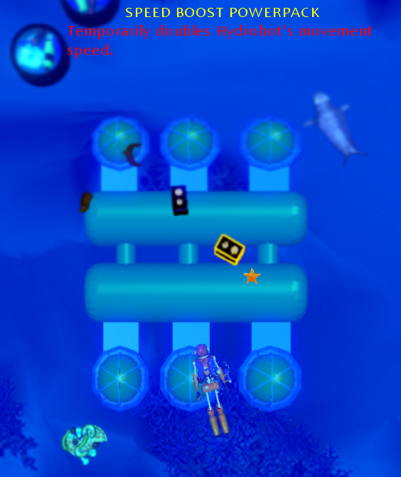

*Figure 5. Powerpack temporarily doubles a Hydrobot’s attribute*

1. Upgrade factories

You can upgrade factories to make them work more efficiently. The upgrade option can be seen in the research facility screen which is opened when you right click on the research facility.

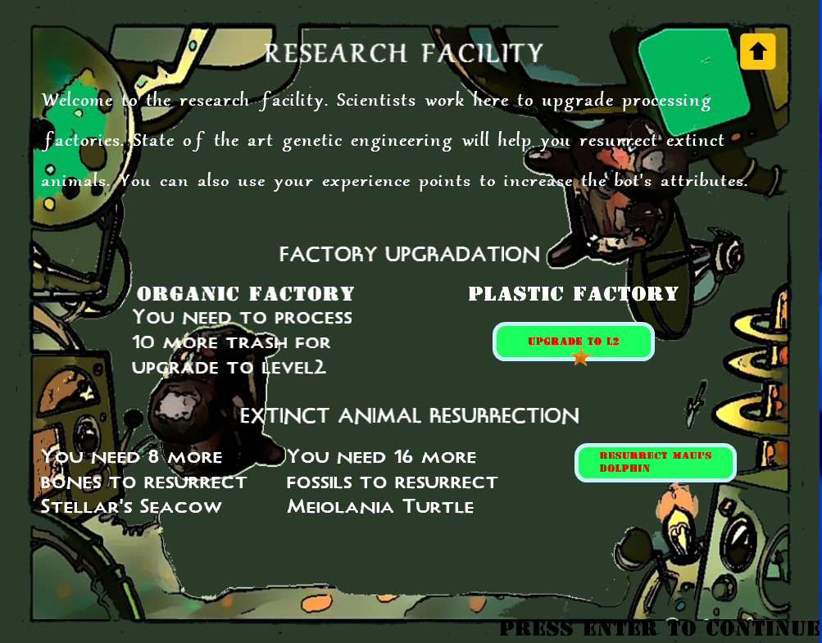

*Figure 6. Factory can be upgraded when requirements have been fulfilled*

1. Heal Sea Animals

Position the starfish-cursor on top of a sea animal, and left click the mouse. You will see green healing bullets being fired. If the fish health is low, the bullet will heal it. The sea animals make pleasant sounds when they are healed. The animal’s health can be seen on a health-bar on top of the screen, when the cursor is on it. Since the hydrobot can understand fish language, you will see some text below the health-bar. Points gained will be displayed in fading green numbers.

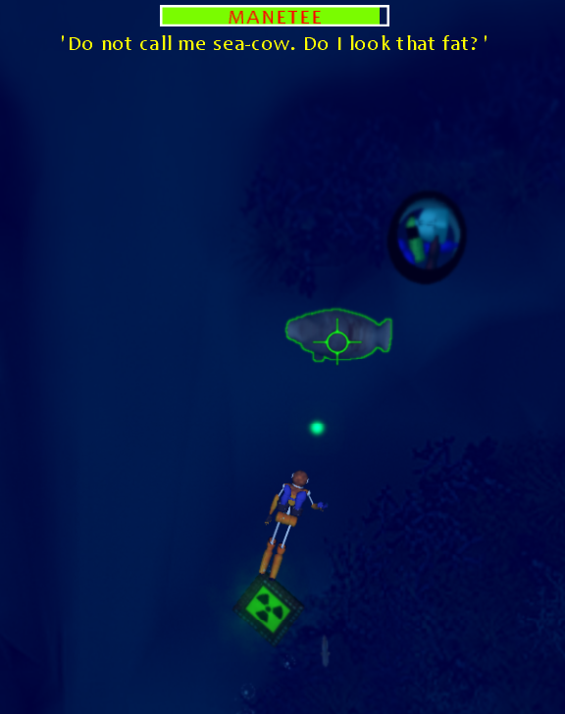

*Figure 7. Healing and communicating with sea animals*

1. Defeat And Teleport Enemies

Position the starfish-cursor on top of an enemy, and left click the mouse. You will see red bullets being fired. It can take many bullets to completely defeat and teleport an enemy. You can see the teleportation status on a bar on top of the screen. The enemy cries out just before he vanishes. Points gained are also displayed.

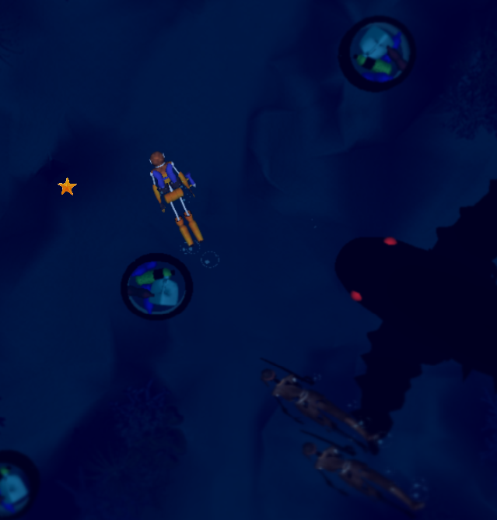

*Figure 8. Battling with enemies and bosses*

1. Switching Bullets

Press ‘space’ to switch between healing and teleporting bullets.

1. Locking Cursor on a Target

Press ‘Caps Lock’ when the cursor is top of the target. The cursor will remain locked on it unless you press ‘Caps Lock’ again or the target moves out of the display screen.

1. Shooting without Moving

Hold ‘Ctrl’ & click or hold the left mouse button to fire bullets in the direction of the cursor.

1. Enter a Shipwreck

Position the hydrobot on top of a shipwreck and double click the mouse. The screen will change and you will find the hydrobot inside a narrow dingy shipwreck.

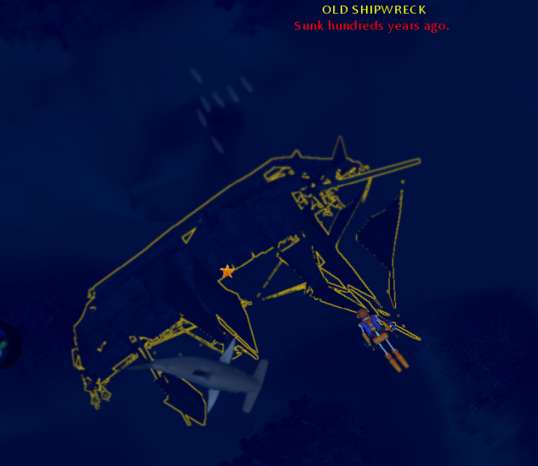

*Figure 9. Enter shipwreck to find treasure*

1. Open Treasure Chests inside Shipwreck

Position the hydrobot on top of a treasure chest and double click to open it. If the chest contains an old painting, the painting will be displayed. If it contains a relic, the skill associated with the relic will be added to the Hydrobot’s skill set. Pressing Enter/Alt closes the painting and relic screen. Little fading green numbers will display the points gained by opening the chest.

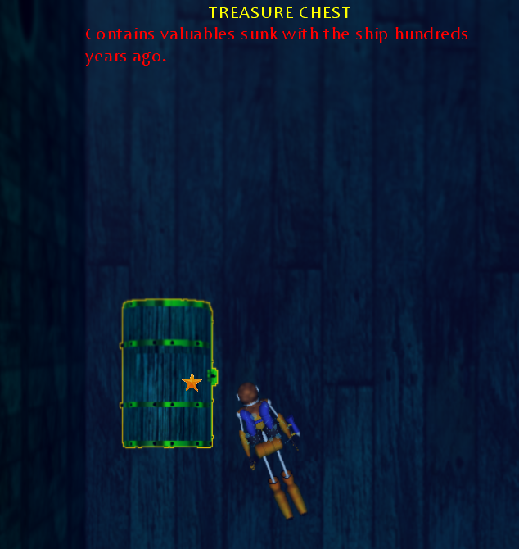

*Figure 10. Treasure chests can be found inside shipwreck*

1. Getting out of a shipwreck

Press ‘Esc’ to exit the shipwreck.

1. Special Skills

There are five skills that can be extracted from the relics in the treasure chests inside shipwrecks. Each of them is unique and different techniques must be used to utilize their power effectively. Every skill usage reduces the Hydrobot’s health. Each skill has a wait-time, so it cannot be used repeatedly.

1. Hermes’ Winged Sandal

Right click the mouse to dart towards the cursor. All enemies in the way will be pushed back, damaged, and stunned. However, the sandal cannot harm sea animals. If a sea animal comes in the path of the sandal, it will stop. The strength of the sandal is dependent on the speed of the hydrobot.

1. Hercules’ Bow

Position the cursor on an enemy and right click the mouse to fire the mighty arrow. The strength of the arrow is dependent on the bullet strength of the hydrobot.

1. Thor’s Hammer

Right click the mouse to use the hammer. The screen will shake with its power and all enemies surrounding the hydrobot will be thrown back and stunned. The strength of the hammer is dependent on the bullet strength of the hydrobot.

1. Achilles’ Armor

Right click to become put on the golden armor. All enemy attacks will amount to nothing when the armor is effective. It only last for short time. The duration is dependent on the shooting rate of the hydrobot.

1. Aphrodite’s Belt

Position the cursor on an enemy and right click the mouse. The enemy will be hypnotized and attack other enemies. However, the hydrobot cannot teleport it while it is hypnotized. The duration is dependent on the Hydrobot’s health point.

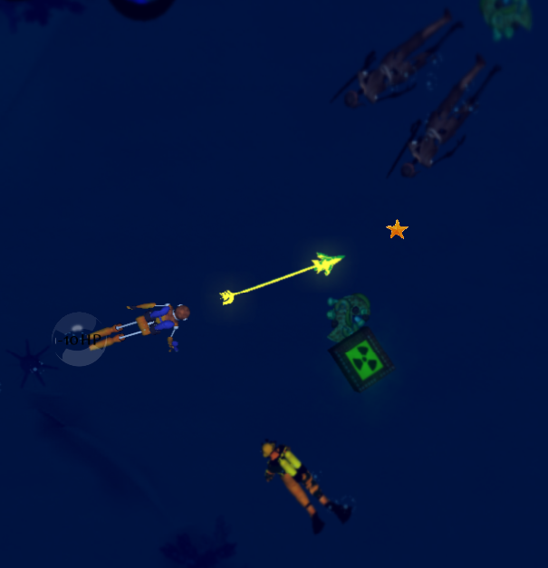

*Figure 11. Special powers help the Hydrobot a lot in battle*

1. Switching Skills

The following numbers are used to select skills:

1 – Hercules’ Bow

2 – Thor’s Hammer

3 – Achilles’ Armor

4 – Hermes’ Winged Sandal

5 – Aphrodite’s Belt

The number’s have no effect when the corresponding relic is not found from the treasure chest.

1. Enhance Attributes

An experience bar is placed on the bottom of the screen. Every action in the game adds experience points to the hydrobot. Having enough experience point results in leveling up to the next experience level. On reaching the next level, 5 points are given to the hydrobot. These points can be used to increase speed, shooting rate, bullet strength and hit points. The attribute board is used to choose and increase attributes. Press ‘I’ to open the attribute board. Click on the attribute boxes to increase them. The bar in the center of the screen shows how many points are remaining. Click on ‘DONE’ or press ‘ENTER’ to resume game. You can also open the attribute board from the research facility screen.

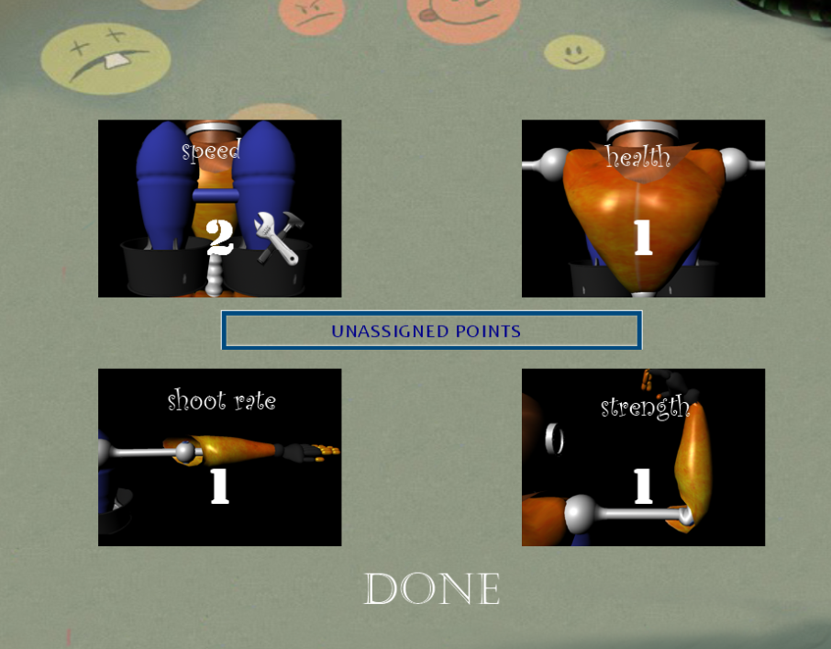

*Figure 12. Increasing Hydrobot’s attributes when leveled up*

1. Resurrect Extinct Sea-Animals

Extinct animals can be resurrected by using a futuristic technology wherein a complete DNA sequence is extracted from fossil/bone fragments. The DNA is injected into a cell which is grown in an artificial womb. In order to initiate this process, you need to find enough bone/fossil fragments. These fragments are inside strange rocks which are found in treasure chests or found while processing trash. The strange rocks need to be collected by pressing ‘z’ and submitted to the research facility by double clicking. When the research lab constructs the entire DNA sequence, it will show a button to start playing the resurrection game. The resurrected animal will act as the Hydrobot’s sidekick.

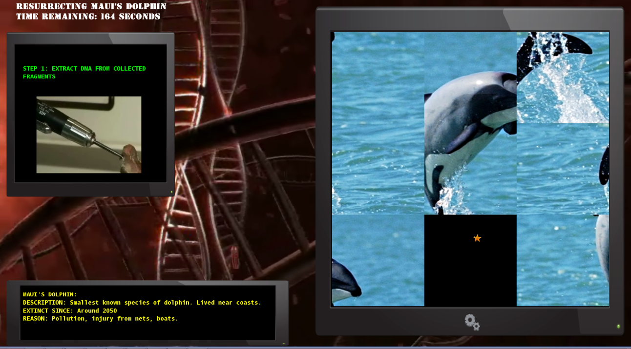

*Figure 13. Solve the puzzle to resurrect an extinct animal*

1. View Level Objective

Click on the target icon C:\Users\Debjyoti\game\Poseidon\PoseidonContent\Image\Miscellaneous\LevelObjectiveIcon.png on the right corner to open the level objective board. It also displays the status or the percentage of the target that has been achieved. Press ‘Enter’ or ‘Escape’ to resume game.

1. View Tip

Click on the ‘t’ icon C:\Users\Debjyoti\game\Poseidon\PoseidonContent\Image\Miscellaneous\tipIcon.png placed just below the level-objective icon on the top right of the screen to view useful tips specific to that level.

1. Mini Games

After every level, there is a mini game. It can be either a quiz game or a typing game.

1. Quiz

Click on the button or type a/b/c/d to answer. Click on ‘NEXT’ or press ‘Enter’ to go to the next question.

1. Type Racing

There is a wait time when the traffic signal on top is red. When the signal turns green, you can start typing. If the word is typed correctly, it is printed in black. If it is incorrect it turns red.

1. Pause Game

Press ‘P’ to pause game. Press ‘P’ again to resume. Pressing ‘Esc’ can also pause the game.

1. Quit Game

Press ‘Esc’ to go to the start screen. Press the down arrow twice to select ‘quit’. Press ‘Enter’.

1. Help Screen

Press ‘Esc’ to go to the start screen. Press the down arrow to select ‘help’. Press ‘Enter’. The help screen will be displayed. Press ‘Enter’ or ‘Esc’ to go back to the start screen.

1. Cut Scenes

Cut scenes are used to narrate the story of the game. Press ‘Enter’ to go to the next cut scene. Cut scene can be skipped by pressing Esc.

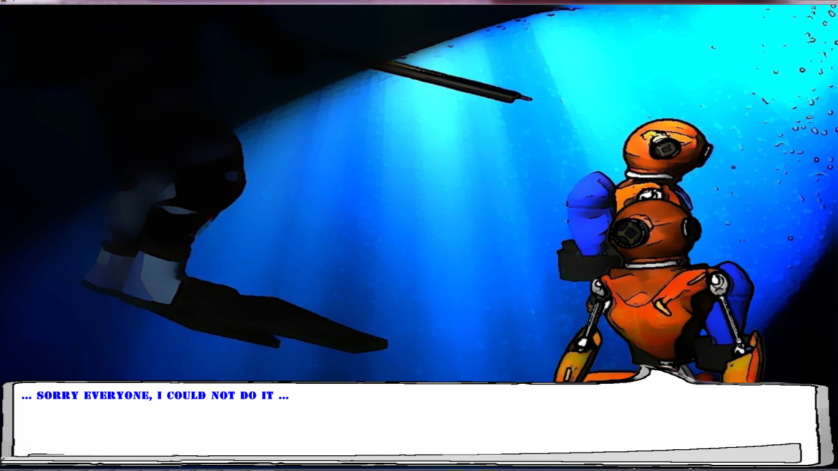

*Figure 14. Cut scene to narrate game’s storyline*